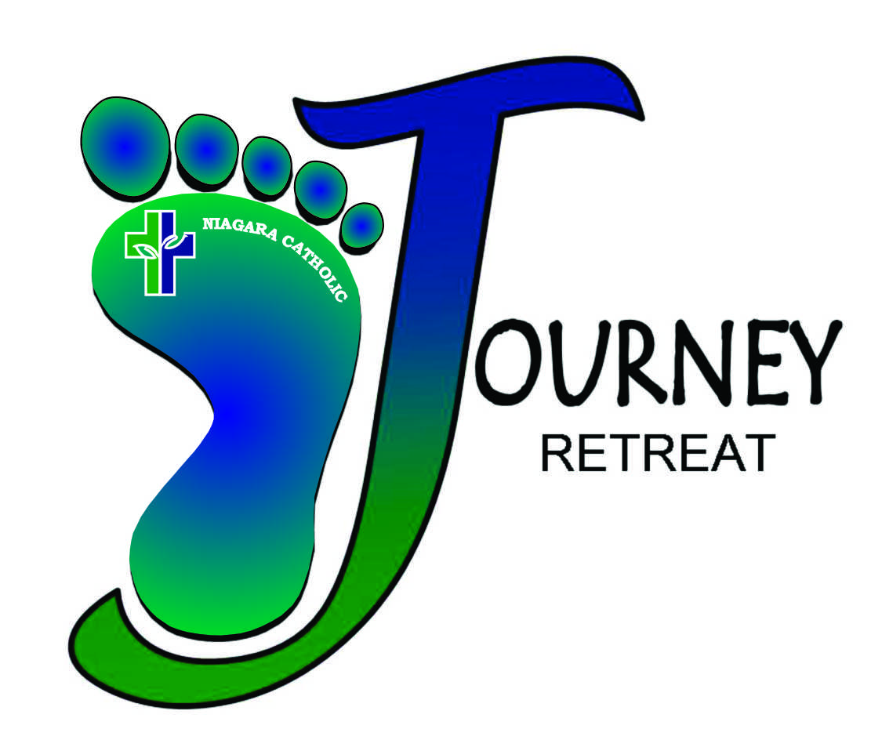

PARENT/ STUDENT PACKAGE

2019-2020

June 2019

Dear Parent/ Guardian,  
  
For over 38 years, grade eight students from the Niagara Catholic District School Board have been given the opportunity to come away from their regular routine of school life and participate in a unique spiritual retreat experience. The Journey Retreat, now in its ninth year, is a two day/one night experience designed to affirm and challenge our students as they grow and live in their faith.

Through a wide variety of experiential opportunities, students will work, play and pray together to build community, explore their own faith journey and be empowered and challenged to walk in the footsteps of Jesus. It is our hope that students will come to see God active in their own lives and return inspired to continue their journey of faith along side their families, their local community as well as globally.

Our Retreat facility is the Our Lady of Grace Spiritual Centre in Ridgeway where students will also explore local outdoor areas such as the Friendship Trail and Bay Beach.

Niagara Catholic supports this retreat by providing a staff team and resource costs. Students are expected to pay **$50.00** (payable to school) towards meals. We also ask each student to bring **SNACKS** that will be shared among the whole class at designated snack times.

The second evening of our Retreat is a special community time as we invite Parents/Guardians to join their young people for a celebration of the Eucharist, followed by dinner. The cost for the dinner is $14.00 per person (please include with student fee). Please arrive at 5:15 pm. Mass begins at 5:30pm with the evening concluding around **7:15** at which time you will be taking your child home with you. Dress is casual for guests, grade 8 students are expected to follow school uniform dress code (blue and white).

To keep the Retreat experience positive for all, it is very important that parents review the enclosed expectations with your child. Should you have any concerns or questions, please speak with your school principal, classroom teacher or with your school’s elementary chaplaincy leader.

We appreciate your support and prayers as we travel together on our faith journeys.

The Journey Retreat Team,

Krista Wood, Ariana Agnino & James Carnegie

Niagara Catholic District School Board

***STUDENT EXPECTATIONS - PARENTS & STUDENTS NEED TO KNOW!***

**1. RESPECT** – for self, classmates, staff, the facility and our environment. Behaviour that is destructive, disobedient or harmful to the community spirit is unacceptable and will not be tolerated. If necessary, after consultation with teachers, parents will be asked to pick up their child. Parents are responsible for any damage.

2. **UNPLUG** – **no electronic games, i-pods, cell phones etc. will be allowed. Leave all valuables at home. A Retreat is about tuning into one another – not tuning others out.**

3. **FOOT WEAR** - For safety/ health reasons, bare feet or socks are not allowed. Please bring a pair of indoor shoes, running shoes for the gym and appropriate outdoor shoes or boots. Depending on the weather, we will be outside in rain, mud and/or deep snow.

4. **DORMS** – Girls’ dormitories are off limits to the boys and vice versa – all times! This is strictly enforced and students will be sent home. At night, students must remain in their assigned dorm.

5. **SNACKS** – All snacks that students bring will be collected at school before boarding the bus and will be kept in the dining room to be SHARED at scheduled snack times. No food or drink is allowed in the dorms. Please note we are a peanut free building. Also NO GUM!!

6. **WATER** – Students must bring a refillable water bottle as we are a ‘plastic bottle free’ zone. We aim to be environmentally friendly and socially responsible.

7. **MEDICATION** – the classroom teacher will hold all medication (including aspirin and Tylenol). Please label and sign permission forms for student’s medication needs.

8. **DRESS CODE** – all classroom rules and school dress codes apply on Retreat as per “Alternate Dress Days”. Blue and White standardized dress code is required for Mass and Family Dinner. Pay careful attention to necessary items to pack.

9. **SLEEP** – Lights out will be at 11pm and students are expected to get a good sleep to be ready to fully participate in Day 2 of the Retreat.

10. **SUPERVISION** – all students must remain in supervised areas at all times.

We have read and fully understand these expectations. We are familiar with the school behaviour and dress code and take full responsibility and accept consequences if these expectations are not followed.

Parent Signature _________________________________ Date______________

Student Signature ______________________________ Date ______________

Please submit with Emergency and Health Information form.

**JOURNEY RETREAT – EMERGENCY & HEALTH INFORMATION FORM**

**PLEASE RETURN TO SCHOOL W/STUDENT EXPECTATIONS FORM**

STUDENT NAME ___________________________________________ Birth date (dd/mm/yyyy)____________________________

Address __________________________________________________________________________________________________

PARENT Contact: Home Phone # _______________________work _______________________cell _________________________

ALTERNATIVE CONTACT: Name ____________________________ Relationship____________Phone # _____________________

HEALTH CARD NUMBER ___________________________

FAMILY DOCTOR ___________________________ phone _________________

NOTE – No medication (except puffers and Epipens) will be left with students. All medication will be held and distributed by supervisors. All medication must be well labeled as to dosage/ frequency and left in the care of classroom Teacher.

NIGHT TIME – Please describe any condition that would require extra or closer supervision during the night and or during free time.

___________________________________________________________________________________________________________

**ALLERGIES:** 🞏 My child has no known allergies at this time OR

🞏 My child is allergic to the following:____________________________________________________________________________

___________________________________________________________________________________________________________

**STUDENT MEDICATION INFORMATION FORM:**

Medication _____________________________Dosage_______________________________Time Day_________________

Medication _____________________________Dosage_______________________________Time Day_________________

Any additional comments regarding medication:

__________________________________________________________________________________________________________

*** Please send your child with only the amount of medication needed for the extent of the Retreat. Each different type of medication must be contained individually and clearly labeled as to student name, type and dosage. Thank you for helping us to adequately meet your child’s needs.

Teachers will have copies of school emergency forms in their possession throughout the Retreat. Please contact the school well before the trip to change any information.

Parent Signature _________________________________

**PACKING LIST – IMPORTANT!**

* **Pack the necessary (i.e. boots, outdoor wear)**
* **DO NOT pack unnecessary extras (too many clothes) and/or items not allowed (i.e. ipods, cell phones, valuables etc.)**

**CLOTHING TO PACK**

|  |
| --- |
| Underclothing/socks (pack extra changes) |
| Shirts – short sleeve, long sleeve, warm sweater |
| Pants - comfortable |
| Indoor shoes |
| Boots – for outdoor hiking and definitely for winter |
| Rainwear – jackets & splash pants |
| Winter – hat, scarf, mitts (water repellent), warm coat |
| Light Jacket/hoodie |
| Pajamas |
| **\*\*\*School uniform dress code for Mass/dinner(blue and white)** |

**PERSONAL HYGIENE**

|  |
| --- |
| Face Cloth & Towel |
| Toothbrush/ toothpaste |
| Hair Brush/ Comb & hair products |
| Deodorant, Soap, Shampoo |
| Sanitary Protection (girls) |
| **\*\*\*we are scent free – no cologne or perfume\*\*\*\*\*** |

**BEDDING**

|  |
| --- |
| Sleeping Bag or Blanket |
| Pillow & pillow case |
| Twin fitted or flat sheet to cover mattress |

**MISCELLANEOUS**

|  |
| --- |
| Small backpack for Hikes |
| Yoga Mat or large beach towel |
| Plastic bag for wet items |
| Bug spray – for outdoor hikes during the spring and fall |

**AND REMEMBER!!!!!!!**

|  |
| --- |
| REFILLABLE WATER BOTTLE |
| SNACK TO SHARE WITH CLASS (baked goods, veggies, fruit, chips, granola bars, cookies, juice, pop) |

**\*\* School Dress Code for “Alternate Dress” days is expected. If outfits for retreat are**

**not appropriate students will be asked to change\*\***